

IT. 3502 - High-Rate Networks

Project 2

Definition of an FTTA loop for the backhaul of equipment in an urban area

GUO Xiaofan

YIN Chenghao

## Overview (GUO Xiaofan & YIN Chenghao)

This report focuses on the fiber optic line design for a specific area, incorporating different station roles (radio sites, fixed network and anchor stations). It considers factors such as network reliability, cost control, redundancy requirements, and terrain limitations to propose a series of design solutions and select the optimal strategy for implementation. The report covers design principles, topology structure, specific line designs, cost estimation and optimization recommendations.

## Circuit Design (GUO Xiaofan & YIN Chenghao)

### Design Principles

1. Network Reliability Priority:

* Key nodes (such as orange NRA/O nodes and green wireless stations) should be connected to anchor stations using dual physically separated return paths to ensure high reliability.

1. Cost Control:

* Avoid unnecessary dual-path setups by optimizing fiber length and selecting suitable topology structures to reduce construction costs.

1. Avoid Using Black Main Roads:

* In fiber optic line design, black main roads should be avoided to minimize construction restrictions and permit costs.

1. Layered Topology Optimization:

* Based on the importance of station roles, adopt a layered design with dual-path connections for key nodes and single-path connections for regular nodes.

1. Future Scalability:

* Reserve space in the fiber layout to facilitate the addition of new nodes or bandwidth upgrades in the future.

### Network Topology Design

#### Topology Types

Based on station distribution and requirements, the following three structures are comprehensively applied:

1. Ring Topology:

* Create a ring connection within each station area to enhance redundancy and reduce single-point failures.

1. Star Topology (Aggregation Node Design):

* Connect stations in an area to an NRA/O node using single-path connections, with the NRA/O node aggregating and connecting to the anchor station.

1. Chain Topology (Serial Design):

* For small-scale or low-traffic areas, stations use a serial design to directly connect to the anchor station, minimizing the total length of fiber optic deployment.

#### Layered Design Concept

1. Core Layer (Red Anchor Station):

* The anchor station aggregates network-wide data and connects to the operator's core network.
* Dual-path access ensures high reliability.

1. Aggregation Layer (Orange NRA/O Nodes):

* Each NRA/O node aggregates traffic from multiple green wireless stations and connects to the anchor station using a dual-path design.

1. Access Layer (Green Wireless Stations):

* Green stations connect to NRA/O nodes via single-path or ring connections; some critical stations can directly connect to the anchor station via dual-path connections.

### Line Design Details

#### Station Classification and Roles

1. Green Stations (Wireless Stations):

* Primary Function: Provide wireless communication services (5G/4G base stations).
* Design Requirements: High bandwidth and low latency; suitable for dual-path or ring designs.

1. Orange Stations (NRA/O Fixed Network Nodes):

* Primary Function: Aggregate traffic from fixed network users (e.g., residential and enterprise broadband) and handle return paths.
* Design Requirements: Dual-path connections to anchor stations for high reliability.

1. Red Stations (Anchor Stations):

* Primary Function: Serve as the core aggregation point, connecting to the upstream network.
* Design Requirements: High reliability with dual-path inputs supporting large volumes of traffic.

#### Specific Line Design Solutions

1. **Design 1**

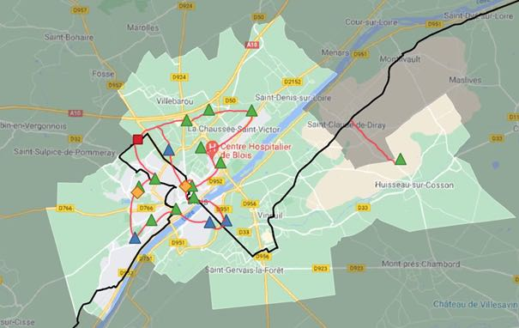

**Description:**

* The red line is compact and centralized, focusing on the most critical areas within the urban core.
* It starts at the central anchor station and primarily connects nearby radio stations in the northwest direction.
* The layout avoids the black main road entirely and creates a simple, short-distance path with minimal intersections or branching.
* There is little extension into suburban or peripheral areas, keeping the focus on dense, high-traffic zones.

**Advantages:**

1. Path Optimization and Shortened Distance

* The short and direct path minimizes the fiber deployment length, significantly lowering construction costs.

1. Avoiding Main Roads to Reduce Risk

* The red line bypasses the black main road, reducing construction coordination constraints and potential risks from road-related failures.

1. Efficient Central Network Coverage

* Optimizes connectivity for key stations in densely populated urban areas where demand for coverage is highest.

1. Simple and Low-Cost Deployment

* The straightforward layout reduces complexity, ensuring quick and cost-effective deployment.

1. **Design 2**

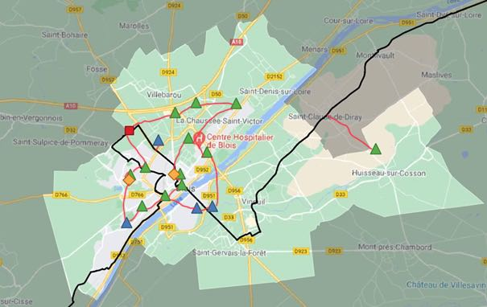

**Description:**

* The red line adopts a balanced and expanded layout, connecting radio stations in both northern and southern areas while still originating from the central anchor station.
* Compared to the first map, this design reaches beyond the city core, connecting more stations in the outlying urban zones.
* It forms two distinct branches: one extending northward towards suburban stations and the other southward to provide additional coverage.
* The layout remains relatively linear and avoids the black main road, ensuring fewer regulatory constraints.

**Advantages:**

1. Balanced Coverage Expansion

* Connects both urban and peripheral stations, achieving better geographic balance without sacrificing efficiency.

1. Avoiding Main Roads to Reduce Risk

* The red line continues to avoid the main road, reducing approval issues and risk of disruptions.

1. Optimized for Medium-Range Connectivity

* Reaches more dispersed stations compared to the first map while still maintaining a relatively simple path structure.

1. Cost-Efficient Deployment

* Balanced route planning avoids difficult terrains, keeping construction costs manageable.

1. **Design 3**

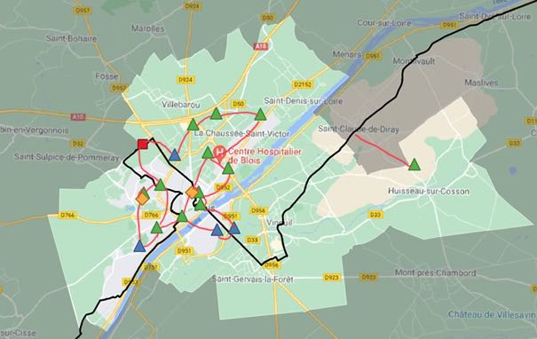

**Description:**

* The red line adopts a comprehensive and redundant layout to cover a larger geographic area.
* From the central anchor station, the line extends into multiple directions, forming a network with intersections and branches.
* A prominent branch heads northeast, connecting far-reaching radio stations located in suburban and rural areas.
* Additionally, the central area forms a high-density network with overlapping connections, improving redundancy.
* Compared to the first two maps, this design prioritizes network robustness and broad coverage over simplicity or cost-efficiency.

**Advantages:**

1. Enhanced Network Redundancy

* Multiple intersections and overlapping paths ensure a fail-safe system, enhancing reliability in case of line disruptions.

1. Wide Area and Remote Coverage

* Extends the network to reach far northeastern stations, providing broad coverage for suburban and rural zones.

1. Independent Return Path

* The redundant layout ensures that data has alternative routes to return to the anchor station, even if other paths fail.

1. Optimized for High Reliability

* The comprehensive layout supports critical infrastructure where network downtime is not acceptable, improving overall system stability.

### Cost and Risk Assessment

1. Cost Control:

* Ring and star topologies avoid unnecessary fiber deployment, and serial designs further reduce overall costs.
* Combining wireless return and fiber deployment reduces complexity and cost for remote stations.

1. Construction Risks:

* Avoid using black main roads to minimize risks related to approvals and construction in restricted areas.
* Use existing public facilities in complex terrains (e.g., rivers, elevated areas) to reduce construction time and difficulty.

### Conclusion

By integrating compact, balanced, and redundant fiber connection strategies, the three designs collectively achieve a balance between cost-efficiency, reliability, and coverage.

* The first design focuses on centralized and compact connectivity, optimizing the network for high-demand urban areas with minimal deployment distance and reduced construction costs.
* The second design expands coverage to both northern and southern zones, offering a balanced approach that connects dispersed stations efficiently while maintaining a straightforward layout.
* The third design prioritizes broad coverage and network redundancy, extending connections to remote areas and ensuring reliable data transmission with multiple alternative paths.

By avoiding the black main road, these designs reduce regulatory risks and potential points of failure. The strategic combination of direct paths, extended coverage, and overlapping connections ensures the network remains scalable, flexible, and robust to meet future demands for expansion and increased traffic.